Group Policy & Procedure | Document No. | P-POL-009
Group Supply Chain | Ver. No. | Rev Date | 0.4 | 08 APR 2026
Title: BPI Procurement Policy | Effective Date | 08 April 2026

BUKHATIR GROUP
Strength through Diversity

Group Policy and Procedure
Group Supply Chain (GSC)
BPI Procurement Policy
Services Procurement via Group Channel

Document No: P-POL-009

Copyright © 2026 Bukhatir Group

Revision Control
This document is issued under the authority of Bukhatir Group and applies when carrying out the activities described. Revisions may be issued as necessary under the authority of the Group Head of Procurement. Revision history is recorded below with every revised policy.

Revision History
Ver. No. | Effective Date | Description
02 | September 2016 | Original Procurement Policy
0.3 | March 2026 | Procurement Policy – BPI Procurement Policy
0.4 | 08 April 2026 | Redesign, content modernization & flowcharts – BPI Procurement Policy

Revision Sign-Off
Approving Committee | Name | Signature
Endorsed by — Group Head of Supply Chain | Mohamad Koussa
Reviewed by — BIIL CEO | Mr. Ayman Ismail
Reviewed by — Group Chief Financial Officer | Mohamad Adnaan Sait
Approved by — Group Vice Chairman & Group CEO | Mr. Salah Bukhatir

Distribution List
# | Departments
1 | Business Unit Procurement Departments
2 | Group Supply Chain (GSC)
3 | Finance, Legal, Compliance, Internal Audit
4 | Business Unit Management

1. Purpose
This policy establishes the mandatory guidelines for procuring services at Bukhatir Precast Industries (BPI) exclusively through the Group Procurement function. It ensures consistency, compliance, transparency and efficiency in BPI's procurement practices, while maximising value for projects and alignment with the overarching Bukhatir Group Procurement Policies (SOP 1–7).

2. Policy Statement
SINGLE CHANNEL — GROUP PROCUREMENT
All procurement of services at BPI — including engagement with contractors, sub-contractors and consultants — SHALL be conducted solely through the designated Group Procurement process. Individual employees are strictly prohibited from directly approaching or engaging any contractor or consultant without prior written approval from the Group Procurement Department.

3. Scope
This policy applies to all employees, contractors and consultants of BPI involved in any aspect of the procurement of services. It is to be read together with SOP 1 (Purchase Requisition), SOP 2 (RFQ), SOP 3 (LOI), SOP 4 (Purchase Orders), SOP 5 (Supplier Evaluation) and SOP 6 (BU–Group Interaction).

4. Group Procurement Process

4.1 Approved Vendor Pool
The Group Procurement Department maintains a formal Approved Vendor Pool for BPI's contractors, sub-contractors and consultants. The pool is reviewed at least annually to confirm continued quality, financial health, HSE performance, compliance and alignment with UAE and industry standards. Vendors not on the pool may not be engaged without a formal onboarding exercise under SOP 5.

4.2 Request for Services
Employees requiring services shall submit a formal Purchase Requisition (PR) via the Oracle system to the Group Procurement team. Every request shall include, as a minimum:
- Project and cost-centre details, including a clear business case.
- Detailed scope of work (Technical and Commercial).
- Budget considerations and confirmed funding source.
- Required timeline and delivery milestones.
- HSE, quality and regulatory requirements where applicable.

4.3 Vendor Selection
The Group Procurement team evaluates each request and selects appropriate vendors from the Approved Vendor Pool using the weighted best-value criteria defined in SOP 2. Selection criteria include:
- Experience, qualifications and relevant track record.
- Past performance on Group projects (OTIF, quality, HSE, responsiveness).
- Cost-effectiveness and Total Cost of Ownership.
- Compliance with UAE regulations, ESG standards and In-Country Value commitments.

4.4 Contracts Approval Process
All contracts with vendors, contractors and consultants shall be routed through the Group Procurement Department for approval. The approval process comprises:
- Review of contract terms and conditions against the Group Standard PO T&Cs (Annex 4A).
- Verification of compliance with BPI policies, the Group Delegation of Authority and relevant UAE law.
- Legal review where value or risk triggers the thresholds defined in SOP 3.
- Final approval by the designated Procurement Officer — no contract may be signed before this step.

4.5 Closed Tenders for Projects
Group Procurement arranges all closed tenders for BPI project works. The tendering process follows SOP 2 and comprises:
- Development of a complete tender dossier (RFQ, CSW, TSW, LOC).
- Issuance of the tender to pre-qualified vendors from the Approved Vendor Pool.
- Receipt and evaluation of sealed bids using the weighted scoring model.
- Selection of the winning bid based on pre-defined commercial, technical, ESG and ICV criteria.
- Documented award decision and issuance of the LOI / PO.

4.6 Communication
All communication with approved vendors shall be conducted through the Group Procurement team. BPI employees shall route all inquiries, clarifications or discussions regarding services through this single channel to ensure proper documentation, audit trail and compliance. Direct side-channel communication with vendors (email, phone or meeting) regarding commercial matters is prohibited.

5. Compliance
DISCIPLINARY CONSEQUENCES
Failure to adhere to this procurement policy may result in disciplinary action, up to and including termination of employment. All BPI employees are expected to comply with this policy and actively promote a culture of accountability, ethics and transparency in procurement.

6. Review & Amendments
This policy shall be reviewed annually and updated as necessary to reflect changes in UAE regulations, industry best practices, or the organisational needs of BPI and the Group. Employees shall be notified in writing of any amendments via the Group Supply Chain communication channels.

7. Effective Date
This policy is effective from 08 April 2026 and supersedes the prior BPI procurement instruction dated 01 October 2024.

8. Flowchart
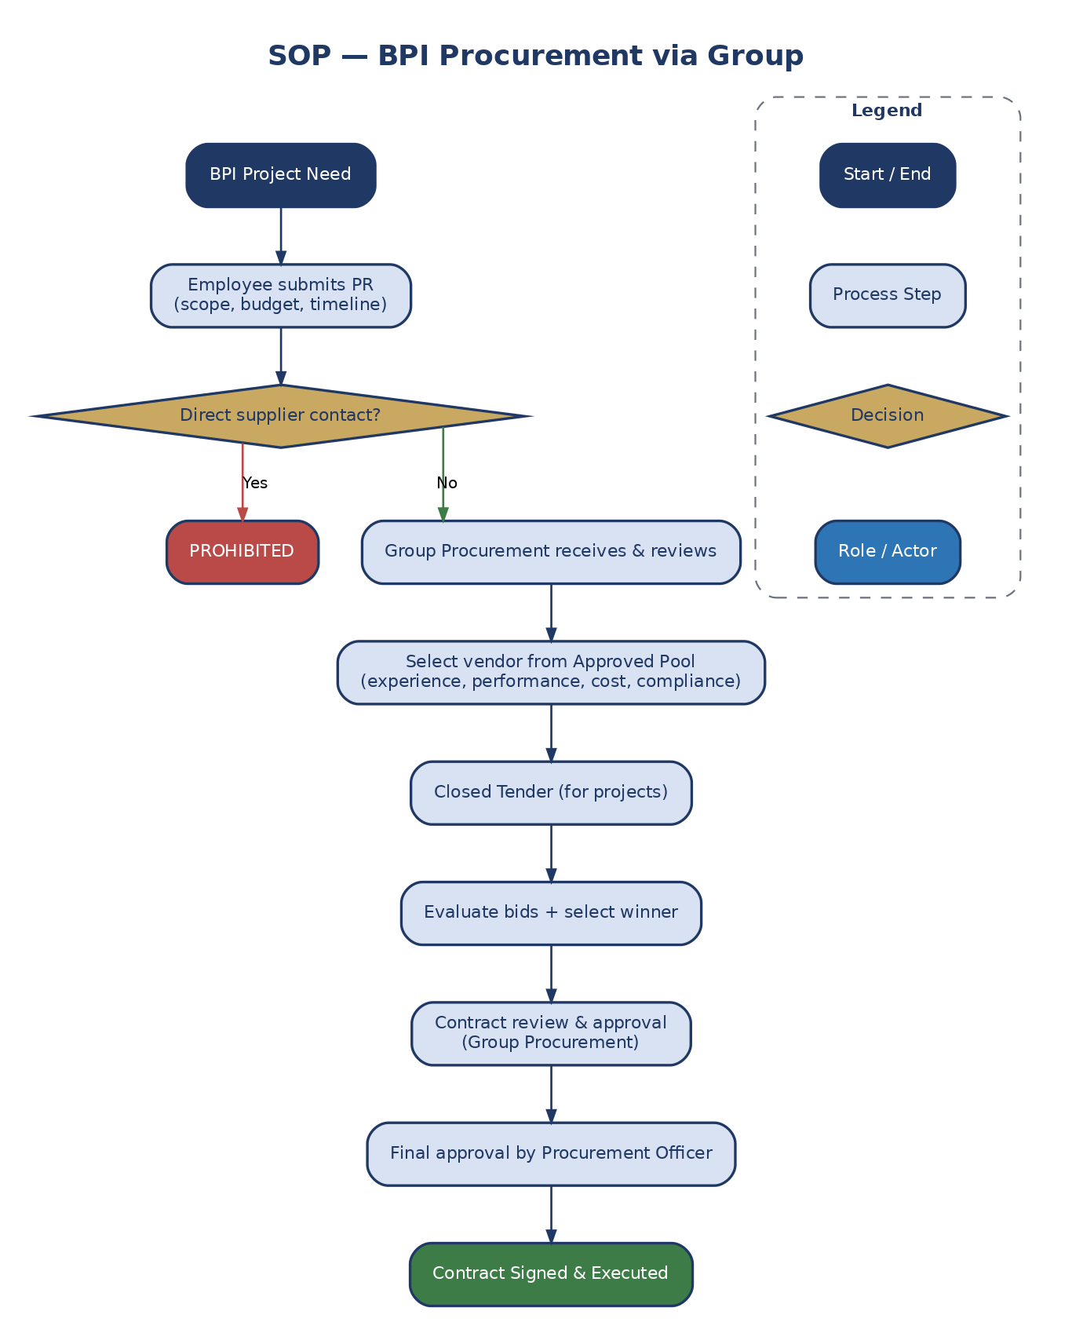
Figure 10: BPI Procurement via Group Channel

9. Definitions & Acronyms
Acronym / Term | Definition
AED | United Arab Emirates Dirham
BPI | Bukhatir Precast Industries
BU | Business Unit
DOA | Delegation of Authority
GRN | Goods Received Note
GSC | Group Supply Chain
KPI | Key Performance Indicator
Oracle | Enterprise Resource Planning System
OTIF | On-Time In-Full
PO | Purchase Order
PR | Purchase Requisition
QCS | Quotation Comparison Statement
RFQ | Request for Quotation

