Group Policy & Procedure | Document No. | P-POL-008
Group Supply Chain | Ver. No. | Rev Date | 0.4 | 08 APR 2026
Title: Scrap & Surplus Management | Effective Date | 08 April 2026

BUKHATIR GROUP
Strength through Diversity

Group Policy and Procedure
Group Supply Chain (GSC)
Scrap & Surplus Management
Disposal, Closed Tenders & Proceeds Control

Document No: P-POL-008

Copyright © 2026 Bukhatir Group

Revision Control
This document is issued under the authority of Bukhatir Group and applies when carrying out the activities described. Revisions may be issued as necessary under the authority of the Group Head of Procurement. Revision history is recorded below with every revised policy.

Revision History
Ver. No. | Effective Date | Description
02 | September 2016 | Original Procurement Policy
0.3 | March 2026 | Procurement Policy – Scrap & Surplus Management
0.4 | 08 April 2026 | Redesign, content modernization & flowcharts – Scrap & Surplus Management

Revision Sign-Off
Approving Committee | Name | Signature
Endorsed by — Group Head of Supply Chain | Mohamad Koussa
Reviewed by — BIIL CEO | Mr. Ayman Ismail
Reviewed by — Group Chief Financial Officer | Mohamad Adnaan Sait
Approved by — Group Vice Chairman & Group CEO | Mr. Salah Bukhatir

Distribution List
# | Departments
1 | Business Unit Procurement Departments
2 | Group Supply Chain (GSC)
3 | Finance, Legal, Compliance, Internal Audit
4 | Business Unit Management

1. Purpose & Objective
This SOP defines the responsibilities and process for the management, disposal and sale of scrap, surplus and obsolete materials across Bukhatir Group Business Units. The objectives are to inform Management on reuse versus disposal decisions, and to ensure the best achievable market price is obtained on all scrap sales through a transparent, auditable process.

2. Scope
This policy applies to all 100%-owned Business Units of Bukhatir Group and to any scrap, surplus inventory, obsolete assets, used equipment, vehicles, fixtures or leftover construction materials that are no longer required for operations.

3. Definitions
Abbreviation / Term | Definition
BL | Buyers List — pre-approved buyers of scrap
BU | Business Unit
BUH | Business Unit Head
DN | Delivery Note
DRF | Disposal Request Form
GP | Group Procurement
PDM | Production Manager
PM | Project Manager
QCS | Quotation Comparison Statement
RFQ | Request for Quotation
SDR | Scrap Disposal Report
SPOC | Single Point of Contact
Scrap / Leftover Inventory | Materials left over from production or consumption; used materials, vehicles, equipment, machinery, household or shop items left behind by tenants
Surplus Material | Excess or unused material after construction, production or project completion that remains fit for reuse

4. Policy
- All scrap and surplus material shall be processed through the BU Central Store in the first instance and classified in the Inventory Management System as Reusable Scrap or Non-Reusable Scrap.
- Each BU shall establish a standing Scrap Committee composed of representatives from Finance, Stores, Procurement and the Department owning the scrap. The Committee evaluates and endorses scrap quotations prior to award.
- BU Procurement shall adopt a closed-tender model when soliciting quotes, engaging in negotiations to secure the most favourable market price. Awards are endorsed by Group Procurement where applicable.
- All requests for disposal of scrap or surplus material with an estimated value above AED 20,000 shall be routed to Group Procurement via a completed Disposal Request Form (DRF), after obtaining the necessary approvals per the Delegation of Authority.
- Scrap and surplus material with an estimated value at or below AED 20,000 may be approved by the BU Head, with the full DRF package attached for record.
- No scrap or surplus material may be removed from Group premises without a system-recorded Delivery Note and supporting Scrap Disposal Report (SDR).
- Proceeds from scrap sales shall be banked into the Group account and recognised by Finance; no cash payments to individuals are permitted.

5. Governance & Ethics
CONFLICT OF INTEREST
Buyers on the approved Buyers List shall not have any direct or indirect relationship with BU employees involved in the scrap process. All Committee members must declare conflicts of interest in writing before quote evaluation. Breach is grounds for disciplinary action and removal of the buyer from the ASL.
- Segregation of duties: the individual preparing the DRF shall not also approve the award.
- Buyers List is maintained by Group Procurement and reviewed at least annually.
- All scrap transactions are subject to Internal Audit review.

6. Environmental & ESG Considerations
Disposal of scrap and surplus materials shall comply with UAE environmental regulations and the Group Sustainability Policy. Preference shall be given to buyers who demonstrate responsible recycling, safe handling of hazardous materials, and proof of legitimate downstream processing. Hazardous waste shall only be disposed of through licensed waste contractors.

7. Detailed Procedure
- Source department identifies scrap / surplus and notifies BU Stores and BU Procurement.
- Items are transferred to the central store, inspected, weighed / counted and classified.
- BU Procurement prepares the DRF with full description, quantity, condition and photographs.
- Scrap Committee convenes, reviews and endorses the DRF.
- Closed RFQ is issued to buyers on the approved Buyers List (minimum three buyers).
- Bids are received sealed; QCS is prepared ranking bids from highest to lowest.
- Approval obtained: BUH (≤ AED 20K) or Group Procurement endorsement (> AED 20K).
- Delivery Note issued; items released to the winning buyer against proof of payment.
- SDR completed; proceeds recorded by Finance; Inventory System updated.

8. Flowchart
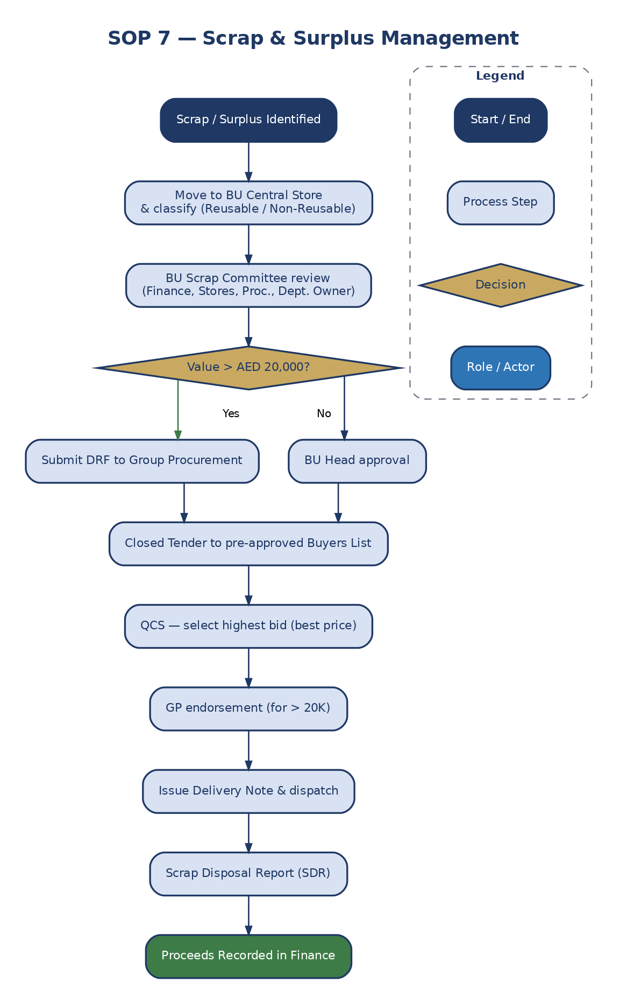
Figure 9: Scrap & Surplus Management Workflow

