Group Policy & Procedure | Document No. | P-POL-007
Group Supply Chain | Ver. No. | Rev Date | 0.4 | 08 APR 2026
Title: BU Procurement Interaction | Effective Date | 08 April 2026

BUKHATIR GROUP
Strength through Diversity

Group Policy and Procedure
Group Supply Chain (GSC)
BU Procurement Interaction
BU ↔ Group Supply Chain Operating Model

Document No: P-POL-007

Copyright © 2026 Bukhatir Group

Revision Control
This document is issued under the authority of Bukhatir Group and applies when carrying out the activities described. Revisions may be issued as necessary under the authority of the Group Head of Procurement. Revision history is recorded below with every revised policy.

Revision History
Ver. No. | Effective Date | Description
02 | September 2016 | Original Procurement Policy
0.3 | March 2026 | Procurement Policy – BU Procurement Interaction
0.4 | 08 April 2026 | Redesign, content modernization & flowcharts – BU Procurement Interaction

Revision Sign-Off
Approving Committee | Name | Signature
Endorsed by — Group Head of Supply Chain | Mohamad Koussa
Reviewed by — BIIL CEO | Mr. Ayman Ismail
Reviewed by — Group Chief Financial Officer | Mohamad Adnaan Sait
Approved by — Group Vice Chairman & Group CEO | Mr. Salah Bukhatir

Distribution List
# | Departments
1 | Business Unit Procurement Departments
2 | Group Supply Chain (GSC)
3 | Finance, Legal, Compliance, Internal Audit
4 | Business Unit Management

1. Purpose & Objective
This SOP defines how Business Units (BUs) of Bukhatir Group interact with Group Supply Chain (GSC). It is NOT a duplicate of SOP 1–5; rather, it specifies ownership, escalation and shared-service mechanics between BUs and GSC.

2. Scope
Applies to all BUs and to GSC as a shared services function. Operational procurement steps remain governed by SOP 1–5 and are not repeated here.

3. Category Ownership
Procurement categories are classified as either Group-led (governed by framework agreements negotiated by GSC) or BU-led (executed locally by BU Procurement).
Category Type | Examples | Owner
Group-led (Framework) | IT hardware/software, telecom, vehicles, insurance, travel, PPE, banking, professional services panels | GSC
BU-led (Local / Urgent) | BU-specific raw materials, site-specific sub-contracts, local spares, ad-hoc services | BU Procurement
Joint | Large CAPEX, multi-BU sourcing events, strategic vendors | GSC + BU jointly

4. RACI — BU ↔ GSC ↔ Finance ↔ Legal ↔ Compliance
The RACI matrix below defines who is Responsible (R), Accountable (A), Consulted (C) and Informed (I) for each procurement lifecycle step:
- R — Responsible: the individual or team that performs the work.
- A — Accountable: the single owner who approves the work and is ultimately answerable for it.
- C — Consulted: those whose input is sought before a decision; two-way communication.
- I — Informed: those who are kept up to date on progress or decisions; one-way communication.
Lifecycle Step | BU | BU Proc. | GSC | Fin. | Legal | Comp.
Demand Planning | A | R | C | I | I | I
Sourcing Strategy | C | C | A/R | C | C | I
Framework Negotiation | I | C | A/R | C | A | C
Call-off / Local PR | A | R | I | I | I | I
Tender / Award | C | R | A | C | C | C
Contract Execution | I | C | R | C | A | I
Supplier Performance | R | R | A | I | I | C
Exception / Deviation | R | C | C | C | C | A

5. Exception Path — Deviating from Group Frameworks
FORMAL EXCEPTION MECHANISM
A BU may deviate from a Group framework agreement ONLY via a formal written Exception Request. The request must state the business justification, quantified cost/benefit versus the framework, and the risk of non-deviation. Approval requires written endorsement of the GSC Head plus CFO, escalating to CEO where required by DOA.
Exception Requests are logged and tracked by GSC; repeated exceptions in a category trigger a re-tender of the framework.

6. Governance & Escalation
A quarterly GSC–BU Steering Committee reviews framework coverage, savings delivered, exception volume and supplier risk. Unresolved issues escalate to the CFO. Material disputes escalate to the CEO.

7. Flowchart
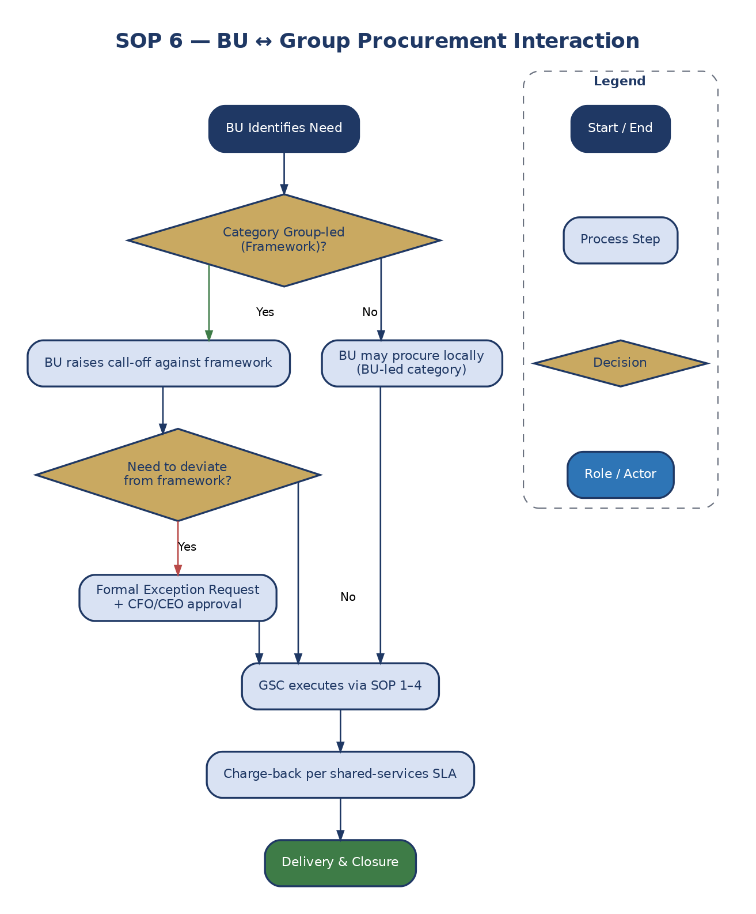
Figure 8: BU ↔ Group Procurement Interaction

8. Definitions & Acronyms
Acronym / Term | Definition
BU | Business Unit
DOA | Delegation of Authority
GSC | Group Supply Chain
KPI | Key Performance Indicator
Oracle | Enterprise Resource Planning System
PO | Purchase Order
PR | Purchase Requisition
RACI | Responsible Accountable Consulted Informed
RFQ | Request for Quotation
SLA | Service Level Agreement

