Group Policy & Procedure | Document No. | P-POL-005
Group Supply Chain | Ver. No. | Rev Date | 0.4 | 08 APR 2026
Title: Purchase Orders | Effective Date | 08 April 2026

BUKHATIR GROUP
Strength through Diversity

Group Policy and Procedure
Group Supply Chain (GSC)
Purchase Orders
Issue, Amendments, GRN & Three-Way Match

Document No: P-POL-005

Copyright © 2026 Bukhatir Group

Revision Control
This document is issued under the authority of Bukhatir Group and applies when carrying out the activities described. Revisions may be issued as necessary under the authority of the Group Head of Procurement. Revision history is recorded below with every revised policy.

Revision History
Ver. No. | Effective Date | Description
02 | September 2016 | Original Procurement Policy
0.3 | March 2026 | Procurement Policy – Purchase Orders
0.4 | 08 April 2026 | Redesign, content modernization & flowcharts – Purchase Orders

Revision Sign-Off
Approving Committee | Name | Signature
Endorsed by — Group Head of Supply Chain | Mohamad Koussa
Reviewed by — BIIL CEO | Mr. Ayman Ismail
Reviewed by — Group Chief Financial Officer | Mohamad Adnaan Sait
Approved by — Group Vice Chairman & Group CEO | Mr. Salah Bukhatir

Distribution List
# | Departments
1 | Business Unit Procurement Departments
2 | Group Supply Chain (GSC)
3 | Finance, Legal, Compliance, Internal Audit
4 | Business Unit Management

1. Purpose & Objective
This SOP defines the process for issuing, amending and closing Purchase Orders (POs) in the Bukhatir Group Oracle system. Standard Terms and Conditions (T&Cs) are auto-selected within Oracle when raising a PO and do not require manual selection.

2. Scope
Applies to all POs raised by the Group. The PO is the formal, auditable instrument authorising a supplier to deliver goods or services.

3. Change-Order Control
VERBAL CHANGES PROHIBITED
No change to PO scope, price, quantity or delivery terms shall be made without a formal, written PO amendment approved per DOA. Verbal instructions to suppliers are strictly prohibited and shall not be honoured for payment.

4. Goods Receipt Note (GRN) & Three-Way Match
Payment shall only be released after a mandatory, system-enforced three-way match of PO, GRN and Invoice:
- PO: raised, approved and dispatched to the supplier via Oracle.
- GRN: recorded in Oracle upon physical receipt, confirming quantity, quality and condition.
- Invoice: received, matched against PO line items and GRN quantities.
Any mismatch shall hold payment until investigated and resolved. Tolerances (e.g. ±2% value, ±5% quantity) are defined in the Oracle configuration.

5. Split-PO Prohibition
ANTI-CIRCUMVENTION RULE
Splitting a procurement requirement into multiple POs to bring individual values below a Delegation of Authority threshold is strictly prohibited. This is treated as a disciplinary matter and, where a supplier is complicit, grounds for ASL removal.

6. Detailed Procedure
- Upon award, BU Procurement raises the PO in Oracle (T&Cs are auto-applied by the system).
- The PO is routed for approval per DOA within Oracle.
- Approved POs are issued to the supplier.
- On delivery, the Receiver records the GRN in Oracle.
- Supplier submits the invoice; Oracle performs the three-way match.
- Any amendments require a formal PO change order through the same approval chain.

7. Flowchart
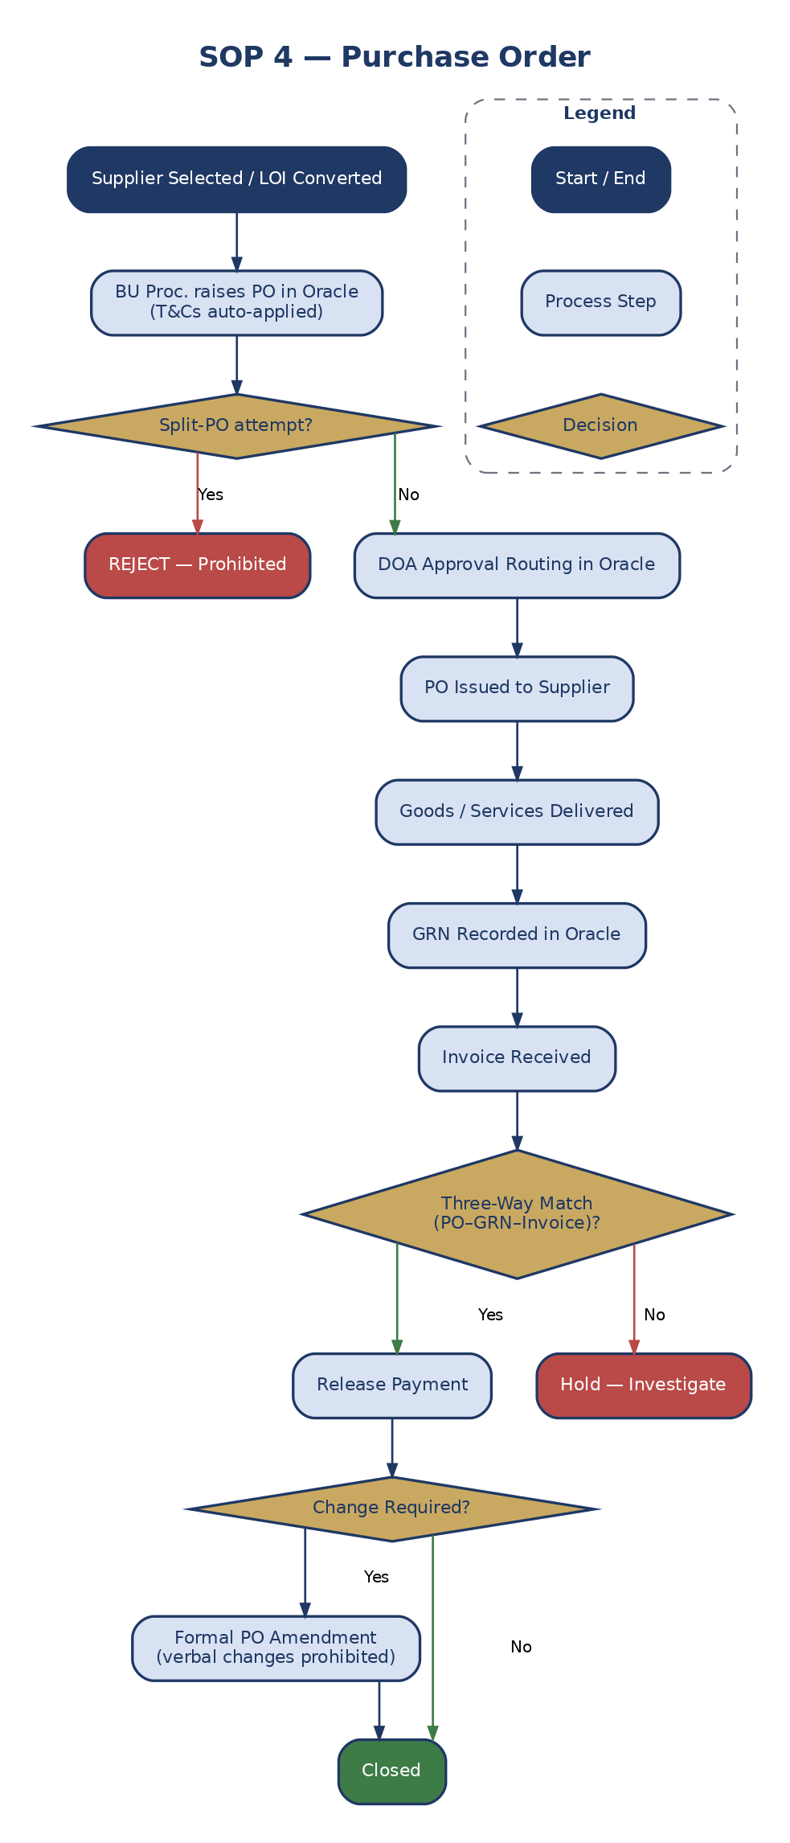
Figure 7: Purchase Order Workflow

8. Definitions & Acronyms
Acronym / Term | Definition
BU | Business Unit
DOA | Delegation of Authority
GRN | Goods Received Note
GSC | Group Supply Chain
LPO | Local Purchase Order
OTIF | On-Time In-Full
PO | Purchase Order
PR | Purchase Requisition
T&Cs | Terms and Conditions

