Group Policy & Procedure | Document No. | P-POL-004
Group Supply Chain | Ver. No. | Rev Date | 0.4 | 08 APR 2026
Title: Letter of Intent | Effective Date | 08 April 2026

BUKHATIR GROUP
Strength through Diversity

Group Policy and Procedure
Group Supply Chain (GSC)
Letter of Intent
Conditional Commitment & Conversion

Document No: P-POL-004

Copyright © 2026 Bukhatir Group

Revision Control
This document is issued under the authority of Bukhatir Group and applies when carrying out the activities described. Revisions may be issued as necessary under the authority of the Group Head of Procurement. Revision history is recorded below with every revised policy.

Revision History
Ver. No. | Effective Date | Description
02 | September 2016 | Original Procurement Policy
0.3 | March 2026 | Procurement Policy – Letter of Intent
0.4 | 08 April 2026 | Redesign, content modernization & flowcharts – Letter of Intent

Revision Sign-Off
Approving Committee | Name | Signature
Endorsed by — Group Head of Supply Chain | Mohamad Koussa
Reviewed by — BIIL CEO | Mr. Ayman Ismail
Reviewed by — Group Chief Financial Officer | Mohamad Adnaan Sait
Approved by — Group Vice Chairman & Group CEO | Mr. Salah Bukhatir

Distribution List
# | Departments
1 | Business Unit Procurement Departments
2 | Group Supply Chain (GSC)
3 | Finance, Legal, Compliance, Internal Audit
4 | Business Unit Management

1. Purpose & Objective
This SOP defines the process for issuing a Letter of Intent (LOI) to a successful supplier or sub-contractor when a full contract or Local Purchase Order (LPO) cannot be immediately executed. In the Bukhatir Group, orders are primarily confirmed via LPO in Oracle; however, this SOP remains available whenever an LOI is needed — typically for orders at or above AED 500,000 where contract formalisation takes time.

2. Scope
Applies to all LOIs issued by Bukhatir Group Business Units. LOIs are created and maintained by BU Procurement. This procedure is NOT required for orders below AED 500,000 — those are confirmed directly by LPO.

3. Legal Status — Conditional Commitment, NOT a Contract
LEGAL CLARIFICATION
An LOI is a conditional commitment to enter into a contract subject to the fulfilment of specified conditions precedent. An LOI is NOT itself a binding contract for full scope. Every LOI SHALL state a maximum liability cap and a clear expiry date.

4. Standard LOI Template
A single Group LOI template is maintained by Legal. Deviations require Legal review. BU Procurement shall use the template and include the following mandatory clauses:
- Scope, price and commercial terms.
- Term and expiry date of the LOI itself (not to exceed 30 days without extension).
- Conditions precedent — bank guarantee, insurance certificates, HSE documentation, ADNOC / JAFZA / free-zone permits as applicable.
- Maximum liability cap — the supplier's recoverable amount under the LOI is limited to a stated ceiling.
- Termination on non-fulfilment of conditions precedent.
- Confidentiality and anti-bribery warranties.
- Governing law (UAE) and jurisdiction (DIFC or onshore UAE courts, as specified).

5. LOI Records
BU Procurement shall maintain records of all LOIs issued by their Business Unit, including:
- LOI reference number, supplier, scope and value.
- Issue date, expiry date and status.
- Conditions precedent and their fulfilment status.
- Converted contract / PO reference (once executed).

6. Legal Review Requirement
Legal review is mandatory for any LOI where:
- Value exceeds the Group legal review threshold defined by the DOA.
- The content deviates from the standard template.
- The counterparty is a government, quasi-government or regulated entity.
- The scope involves cross-border delivery or novel risks.

7. Conversion to Contract / LPO
Every LOI shall follow an explicit conversion process:
- Supplier fulfils all conditions precedent and submits evidence to BU Procurement.
- BU Procurement verifies CP fulfilment and updates the LOI records.
- Legal finalises the full contract or BU Procurement raises the LPO in Oracle.
- The full contract / LPO supersedes the LOI.

8. Flowchart
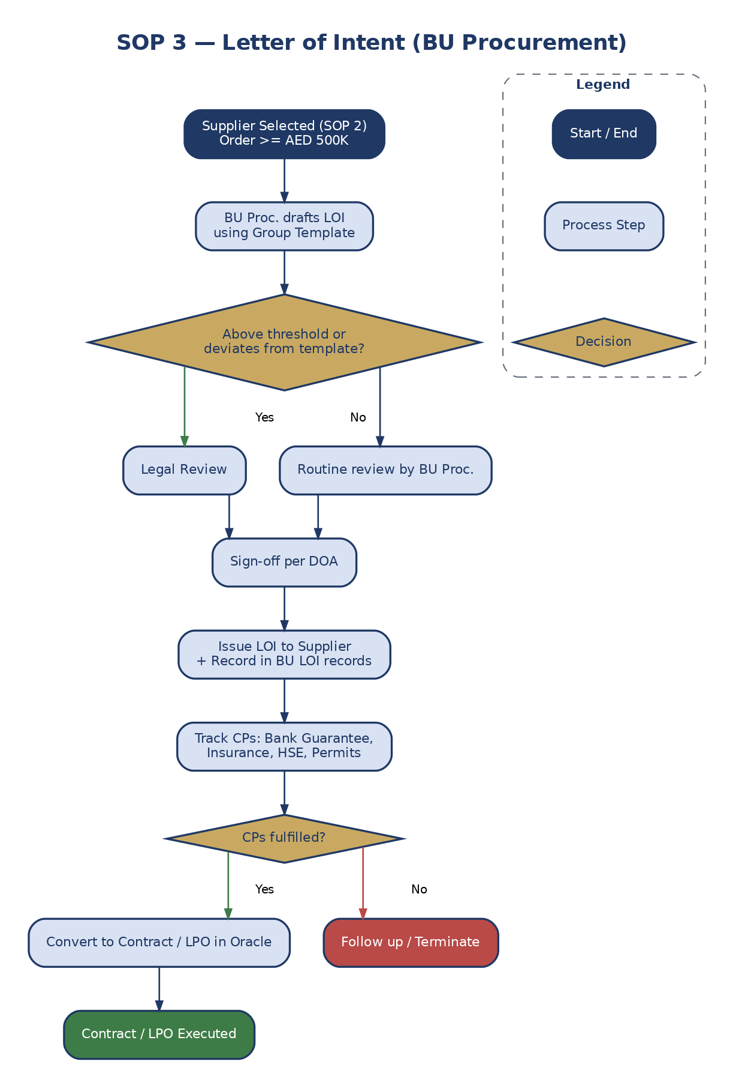
Figure 6: Letter of Intent Workflow

9. Definitions & Acronyms
Acronym / Term | Definition
AED | United Arab Emirates Dirham
BU | Business Unit
DOA | Delegation of Authority
GSC | Group Supply Chain
LOI | Letter of Intent
LPO | Local Purchase Order
Oracle | Enterprise Resource Planning System
PO | Purchase Order
RFQ | Request for Quotation

