Group Policy & Procedure | Document No. | P-POL-003
Group Supply Chain | Ver. No. | Rev Date | 0.4 | 08 APR 2026
Title: Inviting & Assessing Quotations | Effective Date | 08 April 2026

BUKHATIR GROUP
Strength through Diversity

Group Policy and Procedure
Group Supply Chain (GSC)
Inviting & Assessing Quotations
RFQ, Best-Value Evaluation & QCS

Document No: P-POL-003

Copyright © 2026 Bukhatir Group

Revision Control
This document is issued under the authority of Bukhatir Group and applies when carrying out the activities described. Revisions may be issued as necessary under the authority of the Group Head of Procurement. Revision history is recorded below with every revised policy.

Revision History
Ver. No. | Effective Date | Description
02 | September 2016 | Original Procurement Policy
0.3 | March 2026 | Procurement Policy – Inviting & Assessing Quotations
0.4 | 08 April 2026 | Redesign, content modernization & flowcharts – Inviting & Assessing Quotations

Revision Sign-Off
Approving Committee | Name | Signature
Endorsed by — Group Head of Supply Chain | Mohamad Koussa
Reviewed by — BIIL CEO | Mr. Ayman Ismail
Reviewed by — Group Chief Financial Officer | Mohamad Adnaan Sait
Approved by — Group Vice Chairman & Group CEO | Mr. Salah Bukhatir

Distribution List
# | Departments
1 | Business Unit Procurement Departments
2 | Group Supply Chain (GSC)
3 | Finance, Legal, Compliance, Internal Audit
4 | Business Unit Management

1. Purpose & Objective
This SOP defines the process for inviting, evaluating and awarding quotations and proposals across Bukhatir Group. It establishes the selection methodology — lowest price with the best technical match and best overall value — and distinguishes between open RFQs and closed Bids (tenders).

2. Scope
Covers Request for Quotations (RFQ), Bids (closed tenders), Quotation Comparison Sheets (QCS), and Unbudgeted Requests for all Group entities. Purchase Requisitions are processed through Oracle; RFQs are issued and received by email.

3. RFQ vs. Bid — Key Distinction
OPEN RFQ VS. CLOSED BID
An RFQ is an open solicitation sent by email to suppliers on the ASL; responses are received by email. A Bid is a formal closed tender used for high-value or complex procurements; bid documents are issued and received in sealed form with strict confidentiality. Both require a minimum of three (3) quotes.
 | RFQ (Open) | Bid (Closed Tender)
Issuance | Email to ASL suppliers | Formal tender pack — sealed
Receipt | Email response | Sealed envelope / secure portal
Evaluation | BU Procurement — QCS | Tender Committee — QCS
Typical Use | Routine goods & services | Complex, high-value, works
Minimum Quotes | 3 | 3 (or as per tender rules)

4. Selection Philosophy
LOWEST PRICE + BEST TECHNICAL MATCH + BEST OVERALL VALUE
The Group selects the supplier offering the lowest price that also meets or exceeds technical requirements, resulting in the best overall value. Selection is documented in the QCS with clear rationale.

5. Weighted Scoring Model
Every competitive sourcing event shall apply the following weighted scoring model. The Buyer may adjust weights within the stated bands with documented justification.
Evaluation Dimension | Weight | What It Measures
Commercial | 60 – 70% | Price, payment terms, lifecycle cost, warranty, total cost
Technical | 30 – 40% | Specification compliance, quality, delivery capability, references, HSE
Total weight shall always equal 100%. Scores are captured in the QCS together with the evaluator's rationale.

6. Minimum Three Quotes
A minimum of three (3) quotations is mandatory for every procurement. Where fewer than three responses are received, BU Procurement shall document the reason and seek GSC endorsement before proceeding.

7. Sealed-Bid Integrity & Segregation of Duties
For closed Bids (tenders):
- The Bid issuer shall not also be the QCS approver — a two-person minimum rule applies.
- Bids must be received sealed and opened only after the deadline by the Tender Committee.
- Technical and commercial envelopes are evaluated separately.

8. Collusion & Bid-Rigging Controls
The following red flags shall trigger mandatory escalation to Compliance and may result in disqualification and ASL removal:
- Identical or near-identical bids from ostensibly independent suppliers.
- Sequential or "cover" pricing patterns across multiple tenders.
- Bidders declining to quote on a rotational basis.
- Common ownership, addresses, email domains or bank details between bidders.
- Suppliers sharing bid documents or coordinating clarifications.
- Last-minute bid withdrawals that favour a specific bidder.

9. Unbudgeted Requests
LINKHR SYSTEM
Where the approved budget is less than the quotations received, BU Procurement shall raise an Unbudgeted Request on the LinkHR System (Bukhatir internal platform). The request follows the BU's internal approval chain before procurement may proceed.

10. Detailed Procedure
- PR is raised and approved in Oracle by the Requestor / BU.
- BU Procurement prepares the RFQ / Bid pack: Letter of Compliance (LOC), Commercial Scope of Work (CSW) and Technical Scope of Work (TSW).
- RFQ is sent by email to a minimum of three (3) ASL suppliers; or, for closed tenders, a formal Bid pack is issued.
- Suppliers return the LOC, CSW response and TSW response within the stated deadline.
- Technical evaluation is performed by the BU technical reviewer(s).
- Commercial evaluation and negotiations are performed by BU Procurement.
- BU Procurement creates the QCS (Quotation Comparison Sheet), ranking suppliers by lowest price with best technical match.
- QCS is approved as per the Delegation of Authority (DOA).
- If within budget, BU Procurement raises a PO in Oracle. If a Contract or LOI is needed (orders ≥ AED 500K), proceed to SOP 3 / SOP 4.
- If over budget, an Unbudgeted Request is raised on LinkHR for approval before proceeding.

11. LOI Applicability
LOIs are not required for orders below AED 500,000. For orders at or above this threshold, where a full contract or PO cannot be immediately issued, an LOI may be issued per SOP 3 (P-POL-004).

12. Flowchart
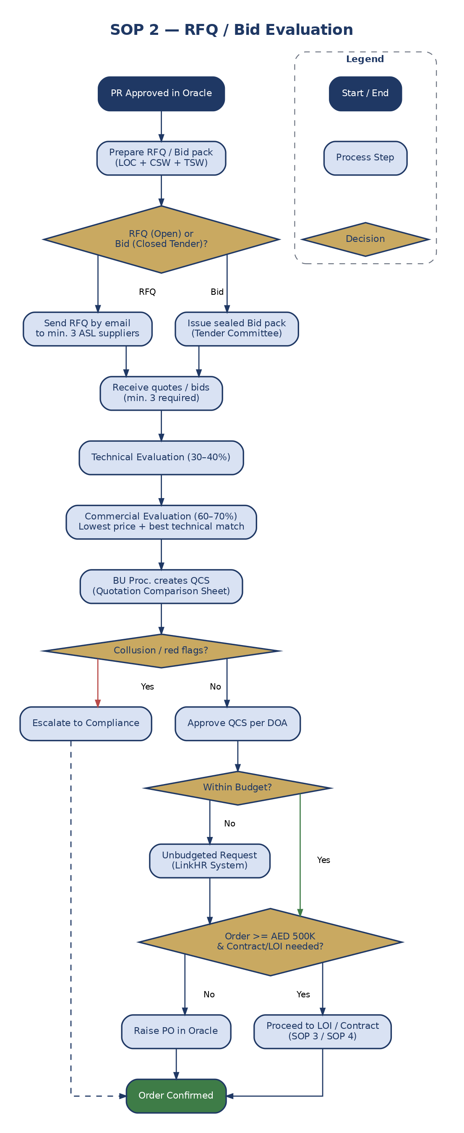
Figure 5: RFQ / Bid Evaluation Workflow

13. Definitions & Acronyms
Acronym / Term | Definition
AED | United Arab Emirates Dirham
ASL | Approved Supplier List
BU | Business Unit
DOA | Delegation of Authority
GSC | Group Supply Chain
KPI | Key Performance Indicator
LinkHR | Bukhatir Group HR System for Unbudgeted Requests
LOC | Letter of Compliance
LPO | Local Purchase Order
Oracle | Enterprise Resource Planning System
PO | Purchase Order
QCS | Quotation Comparison Statement
RFQ | Request for Quotation
TCO | Total Cost of Ownership

