Group Policy & Procedure | Document No. | P-POL-002
Group Supply Chain | Ver. No. | Rev Date | 0.4 | 08 APR 2026
Title: Purchase Requisition | Effective Date | 08 April 2026

BUKHATIR GROUP
Strength through Diversity

Group Policy and Procedure
Group Supply Chain (GSC)
Purchase Requisition
OPEX, CAPEX, Contracts & Sub-contracts

Document No: P-POL-002

Copyright © 2026 Bukhatir Group

Revision Control
This document is issued under the authority of Bukhatir Group and applies when carrying out the activities described. Revisions may be issued as necessary under the authority of the Group Head of Procurement. Revision history is recorded below with every revised policy.

Revision History
Ver. No. | Effective Date | Description
02 | September 2016 | Original Procurement Policy
0.3 | March 2026 | Procurement Policy – Purchase Requisition
0.4 | 08 April 2026 | Redesign, content modernization & flowcharts – Purchase Requisition

Revision Sign-Off
Approving Committee | Name | Signature
Endorsed by — Group Head of Supply Chain | Mohamad Koussa
Reviewed by — BIIL CEO | Mr. Ayman Ismail
Reviewed by — Group Chief Financial Officer | Mohamad Adnaan Sait
Approved by — Group Vice Chairman & Group CEO | Mr. Salah Bukhatir

Distribution List
# | Departments
1 | Business Unit Procurement Departments
2 | Group Supply Chain (GSC)
3 | Finance, Legal, Compliance, Internal Audit
4 | Business Unit Management

1. Purpose & Objective
This policy defines how procurement needs are captured, validated and approved across Bukhatir Group via the Oracle ERP system. It covers OPEX, CAPEX, Contracts and Sub-contracts requisitions.

2. Scope
Applies to all Group Business Units and to all procurement transactions irrespective of value, commodity or geography. Emergency Purchase Requisitions are permitted only under the narrow conditions set out in Section 7.

3. Mandatory PR Fields & Attachments
Every Purchase Requisition raised in the Oracle system shall capture, as a minimum:
- Requestor, Cost Centre, GL Account, Project / Work-Order.
- Detailed description, specification, quantity, unit of measure.
- Required delivery date and delivery location.
- Budget reference and available balance.
- Attachments: technical specification, BOQ, drawings, HSE requirements, business case (CAPEX).
- Supplier preference (if any) with justification.

4. DOA-Aligned Approval Routing
Purchase Requisitions are routed automatically through the Oracle workflow in accordance with the Group Delegation of Authority (DOA).
Value Band (AED) | OPEX | CAPEX | Contracts / Sub-contracts
≤ 50,000 | Dept. Head | Not applicable | Dept. Head + BU Proc.
50,001 – 250,000 | Dept. Head + BU Head | BU Head | BU Head + GSC
250,001 – 1,000,000 | BU Head + CFO | BU Head + CFO | GSC + CFO
1,000,001 – 5,000,000 | CFO + CEO | CFO + CEO | CFO + CEO
> 5,000,000 | CEO + Board | CEO + Board | CEO + Board

5. Mandatory Budget Check
No PR may proceed without a system-enforced budget availability check against the approved annual plan. PRs that fail the budget check are blocked and require formal re-budgeting or CFO exception approval.

6. Demand Aggregation & Framework Agreements
GSC shall aggregate recurring demand into framework agreements to capture volume discounts and reduce transaction cost. BU Procurement shall check for an existing framework before initiating any new sourcing event. Call-offs against frameworks do not require re-tender.

7. Emergency Purchase Requisitions
EMERGENCY DEFINITION
An Emergency PR is limited to situations involving imminent risk to life, safety, critical operations, or regulatory non-compliance that cannot be managed through the standard process. It is NOT a shortcut for poor planning.
Emergency PRs require written justification and post-facto ratification by the BU Head and GSC. Emergency PRs shall not exceed 5% of a BU's annual procurement spend — breach of this KPI triggers a formal review by the CFO.

8. Conflict of Interest Declaration
Every Requestor and approver must confirm, on each PR, that no conflict of interest exists with the intended supplier(s). Declared conflicts are escalated to Compliance and the requestor is recused from the transaction.

9. Flowcharts

9.1 OPEX Purchase Requisition
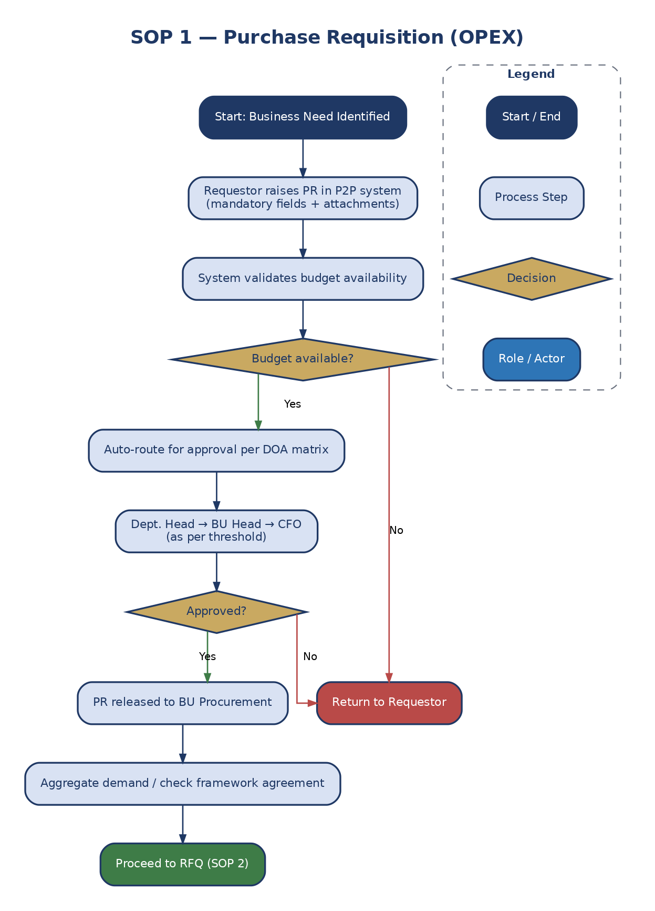
Figure 1: OPEX Purchase Requisition Workflow

9.2 CAPEX Purchase Requisition
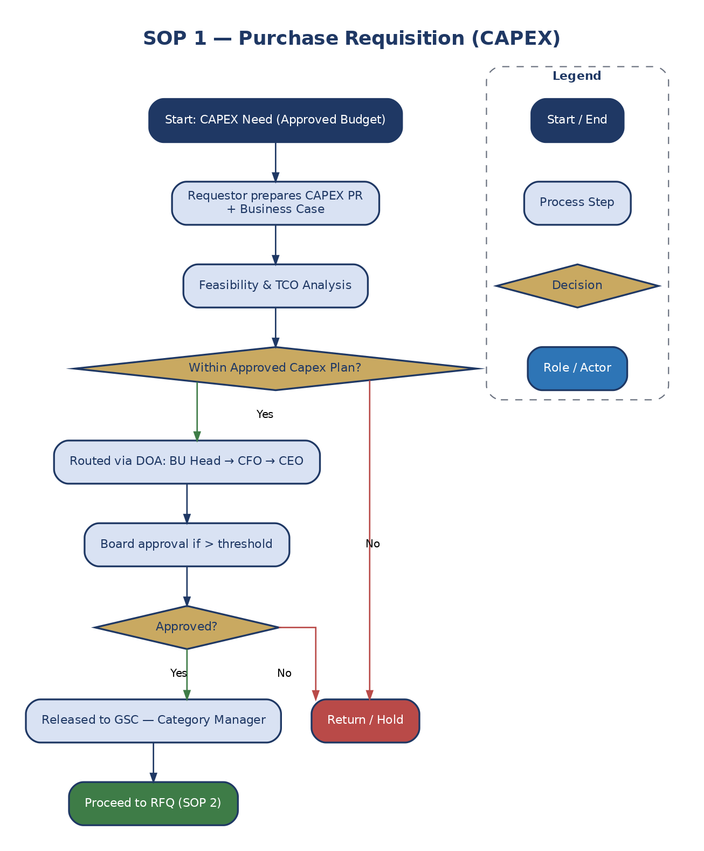
Figure 2: CAPEX Purchase Requisition Workflow

9.3 Contracts Requisition
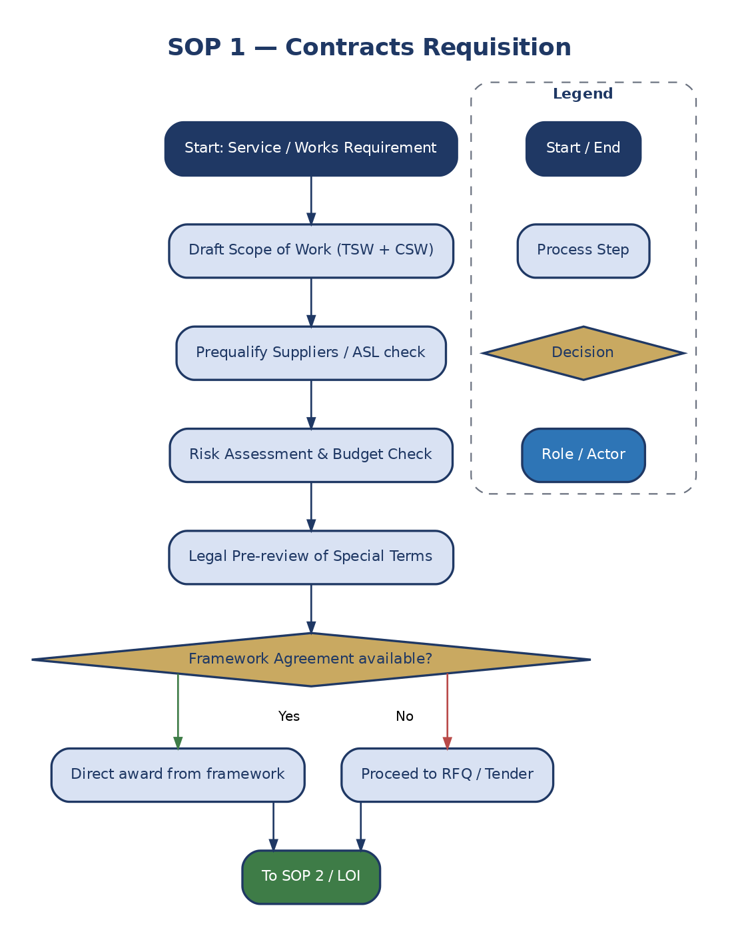
Figure 3: Contracts Requisition Workflow

9.4 Sub-contracts Requisition
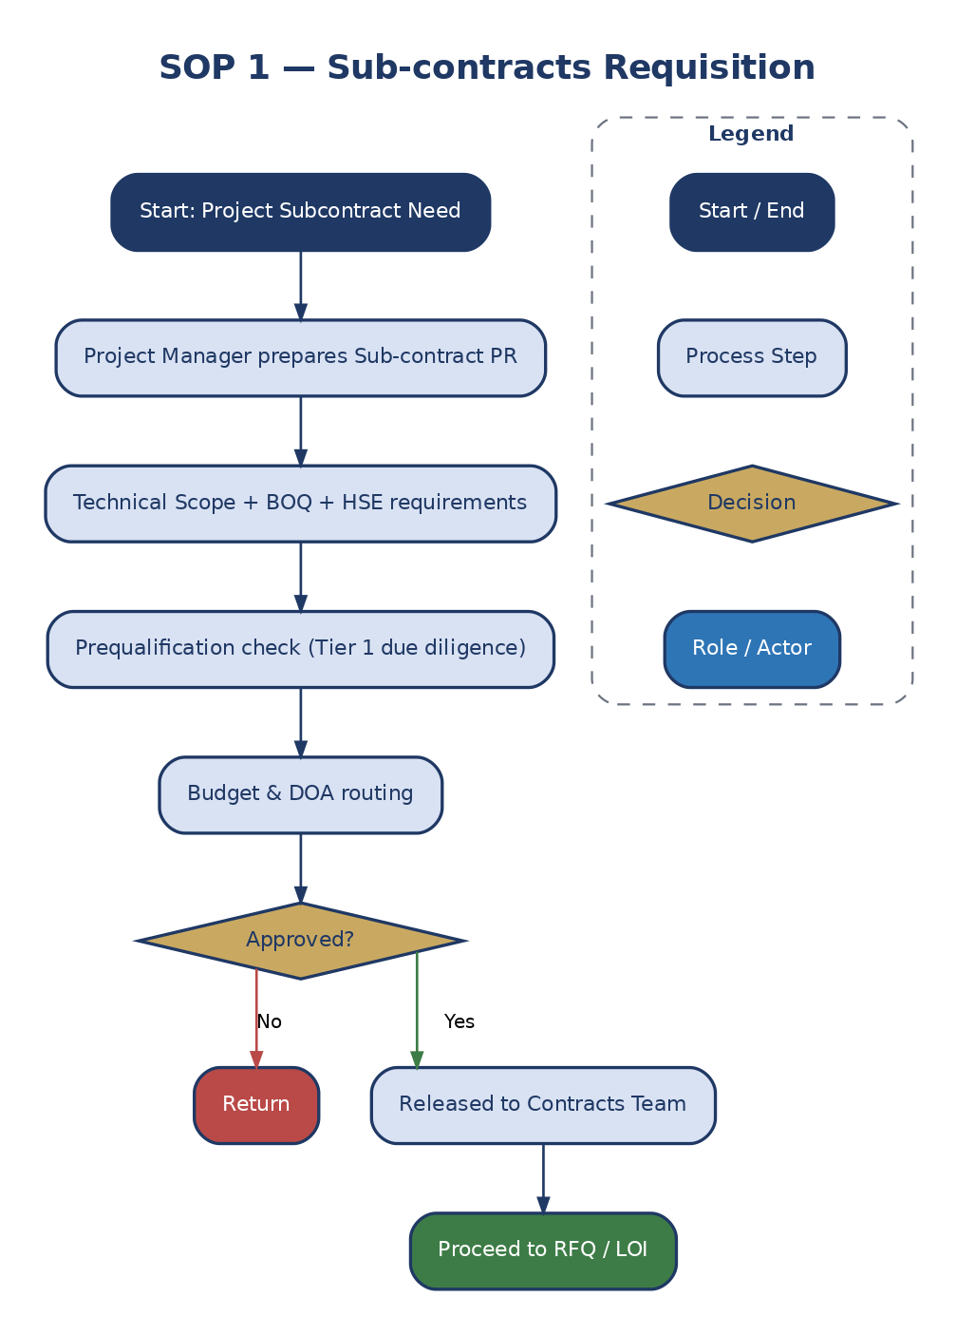
Figure 4: Sub-contracts Requisition Workflow

10. Definitions & Acronyms
Acronym / Term | Definition
BU | Business Unit
CAPEX | Capital Expenditure
COI | Conflict of Interest
DOA | Delegation of Authority
ERP | Enterprise Resource Planning
GSC | Group Supply Chain
KPI | Key Performance Indicator
OPEX | Operating Expenditure
Oracle | Enterprise Resource Planning System
PR | Purchase Requisition

